Experiment – 17

Change Hardware compatibility of a VM (Either by clone/create new one) which is already created and configured using vmware workstation.
AIM:
To modify the hardware compatibility version of an already created and configured virtual machine using VMware Workstation.
SOFTWARE REQUIRED:
VMware Workstation 17, Ubuntu ISO, Host OS: Windows
PROCEDURE:
- Open VMware Workstation 17 from the Start menu to access the virtualization environment on the Windows host system.
- Ensure that the existing virtual machine (for example, “Virtual Machine Ex-17”) has already been created and configured with the required operating system. If not, create and configure it using the standard virtual machine setup process.
- Power on the virtual machine once to verify that it is functioning correctly, then shut it down completely to prepare it for compatibility modification.
- After the virtual machine is powered off, right-click on the selected virtual machine from the library panel and navigate to Manage → Change Hardware Compatibility to launch the Compatibility Wizard.
- In the wizard, select the desired compatibility version, such as Workstation 16.2.x, depending on the required backward compatibility with older VMware versions.
- Proceed by clicking Next and review the summary of changes before completing the process by selecting Finish. If prompted, confirm or specify the virtual machine name and storage location.
- Once the compatibility upgrade or downgrade process is completed, power on the virtual machine to ensure it operates correctly under the selected hardware compatibility version.

IMPLEMENTATION:

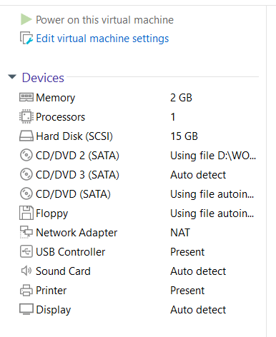

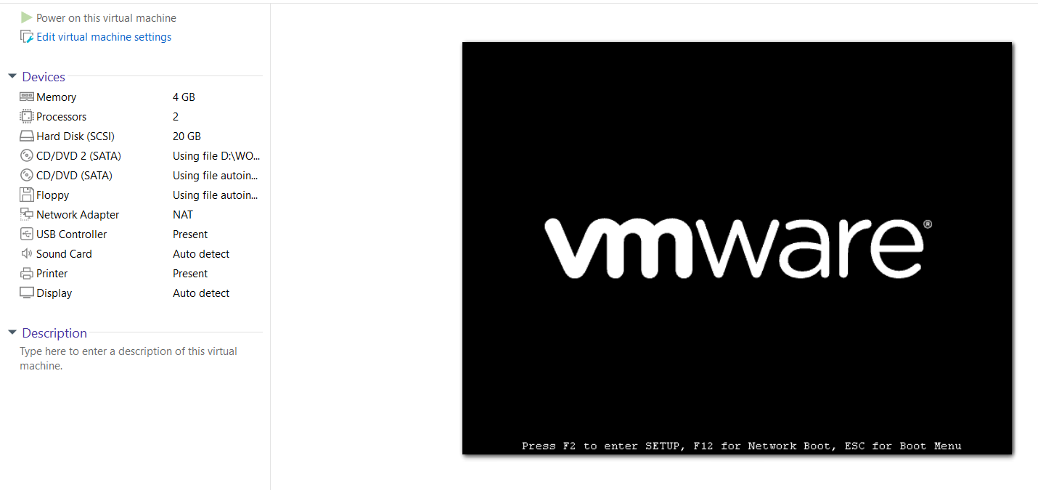

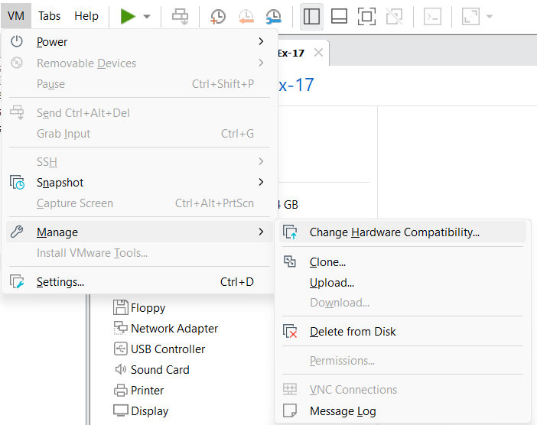

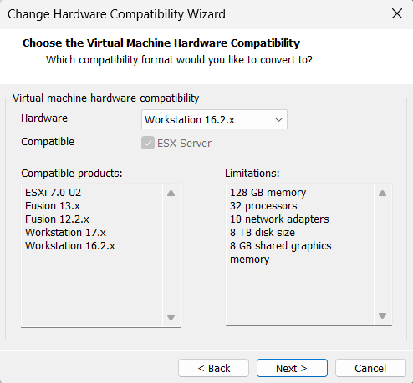

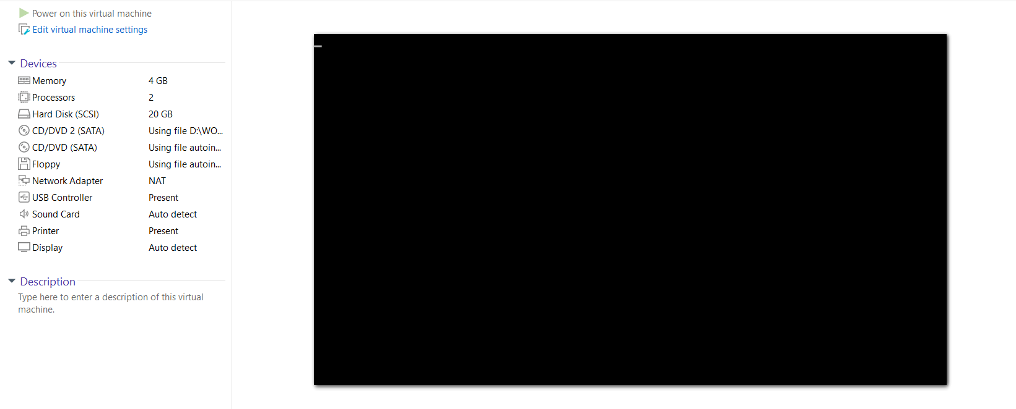

RESULT:
The hardware compatibility version of the virtual machine was successfully modified, and the VM was verified to run properly with the updated compatibility settings.

